**SHIMONI DEMONSTRATION SCHOOL- KIRA**

**MID TERM TW0 EXAMINATIONS, 2023**

**TOP CLASS READING**

**Name ____________________________________________________**

1. Put the first sound.

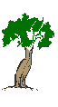______ _______

_____ _____

1. Name these pictures.

|  |  |  |  |
| --- | --- | --- | --- |
|  |  |  |  |
|  |  |  |  |

(Insect**, flower, stool, dress)**

1. Read and draw the pictures.

|  |  |  |  |
| --- | --- | --- | --- |
|  |  |  |  |
| basket | bucket | house | bird |

1. Fill in the missing syllables.

______x  _____n

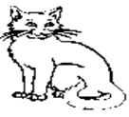________t 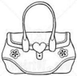_____g 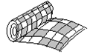_______t

1. Complete correctly.

Here is a__________

That is a_____________

Those are two__________

This is a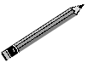______________

1. Fill in the missing sounds.

a, ____,c, ____, ____, f, g____, i

k, l, m,____, ____ , p, ____ , r , s, t, u____

1. Make sentences using (This is a………….)

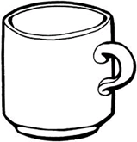__________________________________

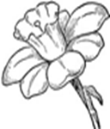__________________________________

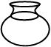______________________________________

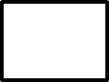 _____________________________________

1. Match capital to small.

A f

B a

C c

D d

E b

F e

1. Fill in the missing sounds.

tr____ ____ t____n

p__ncil f___ ___d

C___p Y____m

1. Write words correctly.

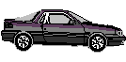 rca __________

ucp __________

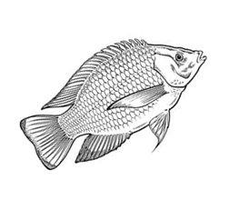fshi __________

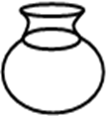tpo __________

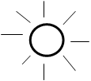usn_________

**END**